Scoil Bhríde
Nurney, Co. Kildare
Telephone: (045) 526767
www.nurneyns.com
sbnurney@gmail.com
13th March 2024
Dear Parents/Guardians

As we draw closer to the end of a yet another school year, please find on the reverse of this note the School Calendar for 2024/25

World Book Day
Thanks to everyone, parents, pupils and staff, for making a big effort last week on World Book Day to dress up. It was great fun! A selection of photos from the day will feature shortly in the Kildare Nationalist!

Book Fair
Thanks to everyone for all their help and support of our School Book Fair last week. Any books paid for but not received by pupils on the day have now been ordered.

Easter Bun Sale for pupils – March 13th!!
Easter Bun Sale for pupils – March 13th with all funds going towards vital new graded readers for all the children and much needed art supplies.
All donations of cakes, buns and treats are most welcome! Please also put your child’s name on any containers and remind them to collect it at the end of the day before going home! Thank you.

Green Day
To celebrate Saint Patrick’s Day and Seachtain na Gaeilge all pupils are being invited to dress up in Green on March 15th. So please start planning your costumes!

Dance lessons for all pupils
A 6-week course of dance classes for all pupils with a specialist instructor started on February 20th. Payment of 5 Euro from each pupil is now due. Thank you.

Swimming
A six-week course of swimming classes in K-Leisure Athy for 4th class starts on April 10th 2024
Payment of 50 Euro from each 4th class pupil is now due. Thank you.

Darkness into Light - Remembrance Walk
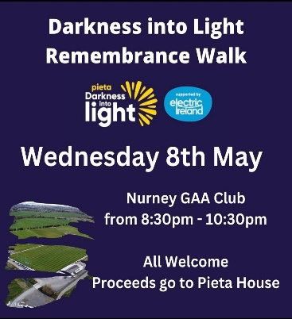
Nurney GAA are hosting a Darkness into Light - Remembrance Walk in Nurney GAA Club on Wednesday May 8th 2024 @ 8.30-10.30pm. ALL proceeds are going to Pieta House.
To mark the event, Kinsella’s have colouring sheets which children can collect from the shop. Once coloured, the art sheets can be returned to Kinsella’s shop by March 15th. They plan to display them as part of the event.

Dates for your diary
- Easter Bun sale for pupils – Wednesday March 13th 2024
- Dress up in Green Day – Friday March 15th 2024
- School will be closed on Monday March 18th for Saint Patrick’s Day.
- School will close for Easter on Friday March 22nd for all pupils at 12.30pm. Buses have been told. The school will re-open on Monday April 8th 2024 for all pupils at 9.20am
- The Parish office wishes to inform you that Communion for families with children in 2nd class will be May 18th 2024 @ 11:30am in Nurney Church
- The Parish office wishes to inform you that Confirmation for families with children in 6th class will be April 20th @ 11:30am in Nurney Church.

Wednesday Note and school information also available
on www.nurneyns.com
Thank you for your co-operation with the above.

__________________________
Dr. Vinny Thorpe – Principal
Ed.D (SL) M.Ed (SL), MA.Comp.Mus, H.Dip.Prim.Ed, H.Dip.Mus.Tech, P.Grad.Dip.Ed.St(SEN), B.Mus.Ed(H.Dip.Ed), Dip.Mus.Ed, T.Dip.ICT

Scoil Bhríde
School Calendar
2024 – 2025

PLEASE NOTE SCHOOL TIMES:
START 9.20am SHARP
FINISH 2pm (JNR & SNR INFANTS) & 3pm (1ST – 6TH)

School re-opens on Wednesday August 28th 2024

October 2024
School closed for Mid-Term:
Monday October 28th – Friday 1st November inclusive

December 2024
School finishes @ 12.30pm Friday 20th December
School closed for Christmas:
Monday 23rd December – Friday 3rd January 2025 inclusive

January 2025
School re-opens Monday 6th January 2025

February 2025
Closed: Saint Brigid’s Day Bank Holiday Monday 3rd February

February 2025
School closed for Mid-Term:
Thursday 20th February – Friday 21st February inclusive

March 2025
Closed: Saint Patrick’s Bank Holiday Monday 17th March

Easter 2025
School finishes @ 12.30pm Friday 11th April
School closed for Easter:
Monday 14th April – Friday 25th April 2025 inclusive
School re-opens Monday 28th April 2025

May 2025
Closed: May Bank Holiday Monday 5th May

June 2025
Closed: June Bank Holiday Monday 2nd June

School closes for Summer @ 12.30pm Friday 20th June

Please note:
This calendar could be subject to change in the event of a closure for an exceptional cause

