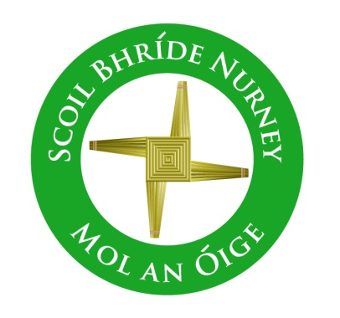
Scoil Bhríde,
Nurney,
Principal – Dr. Vinny Thorpe
Dep. Principal – Catherine Owens

County Kildare.
Tel/Fax: (045)526767
Email: sbnurney@gmail.com
www.nurneyns.com
Roll no: 16345A

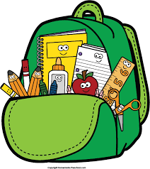
1st Class 2023 – 2024
Book List

- Master your Maths 1st class (Fallons)
- Busy at Maths 1 (Fallons)
- Small World – History, Geography and Science – 1st class (Fallons)
- Ready to Write C1 (introduction to cursive) (EDCO)
- Starlight 1st Class Combined Reading and Skills Book (Folens)
- Starlight 1st Class Skills Book (Folens)
- New Wave English in Practice 1st class (Prim-Ed)
- Starlight 1st Class Core Reader (Folens)
- Céim ar Chéim Reader – Ag an Zú (Fallons)

Please label all of your child’s belongings, stationery, uniform and tracksuit tops, coats, painting shirt etc.

Thank you for your co-operation and looking forward to a great year ahead!
Class Teacher

