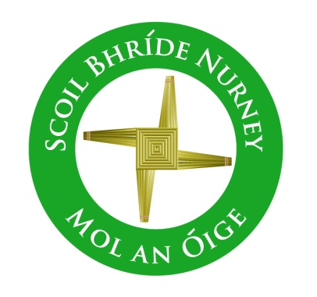
Scoil Bhríde,
Nurney,
Principal – Dr. Vinny Thorpe
Dep. Principal – Catherine Owens

County Kildare.
Tel/Fax: (045)526767
Email: sbnurney@gmail.com
www.nurneyns.com
Roll no: 16345A



5th Class 2026 – 2027
Book List

- Master your Grammar 5 (Fallons)
- Spell it 5 (Folens)
- Master you Maths 5 (Fallons)
- Ready to Write G1 (cursive) (EDCO)
- New Busy at Maths 5 (Fallons)
- Master you English 5 (Fallons)
- Caint is Comhrá 5 (Fallons)
- Léigh sa Bhaile E (Fallons)
- Small World History 5 (Fallons)
- Small World Geography and Science 5 (Fallons)
- ‘Grow in Love’ text book 5th class (veritas)

Please label all of your child’s belongings, stationery, uniform and tracksuit tops, coats etc.


Thank you for your co-operation and looking forward to a great year ahead!
Class Teacher

