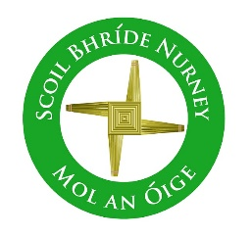
Scoil Bhríde Nurney
Home Learning
September
September Home Learning
Class / Book Name | A Way with Words | Busy at Maths | Small World
Junior Infants | Unit 1 and 2 | Pages 1 – 11 | Pages 1 – 6
Senior Infants | Unit 1 and 2 | Pages 1 – 13 | Pages 1 – 6
1st Class | Unit 1 and 2 | Pages 1 – 23 | Units 1,2,3,4
2nd Class | Unit 1 and 2 | Pages 1 – 24 | Units 1,2,3,4
3rd Class | Unit 1 and 2 | Units 1,2,3,4 | Unit 1 and 2  (History, Geography and Science)
4th Class | Unit 1 and 2 | Units 1,2,3,4 | Unit 1 and 2  (History, Geography and Science)
5th Class | Unit 1 and 2 | Units 1,2,3,4 | Unit 1 and 2  (History, Geography and Science)
6th Class | Unit 1 and 2 | Units 1,2,3,4 | Unit 1 and 2  (History, Geography and Science)
- All the above listed books are available free online at https://www.cjfallon.ie/
- Children can do all of the above work and write all their answers in the one same copy. Please write on the front of this copy your name and the title of “Home-Learning”
- Please write the date on all your work and a subject heading
- Any queries on this work can be sent to your child’s class teacher at sbnurney@gmail.com
- When your child returns to school please give this copy to your class teacher for review
- This work is in line with the work being carried out in class

