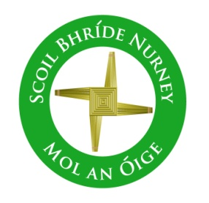

School Self Evaluation Report
School Improvement Plan
2022/23

Process paused to focus on meeting the day-to-day health and safety requirements and practical challenges arising from the COVID-19 pandemic.

The process will be re-booted for the 2023/24 school year, continuing to follow the agreed timeline brought about through our whole school action research project on the process itself.

