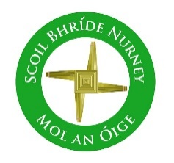
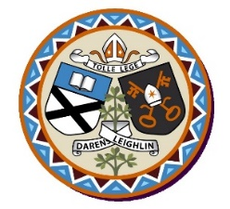
Scoil Bhríde Nurney
Annual Admission Notice
in respect of admissions to the 2026/2027 school year

Admission Policy and Application Form
A copy of the school’s Admission Policy and the Application Form for Admission for the 2026/2027 school year is available as follows: –
To download at: www.nurneyns.com
On request: By emailing sbnurney@gmail.com or writing to Scoil Bhríde, Nurney, County Kildare, R51YC66

Part 1 - Admissions to the 2026/2027 school year

Application and Decision Dates for admission to 2026/2027
The following are the dates applicable for admission to Junior Infants

The school will commence accepting applications for admission on | October 6th
The school shall cease accepting applications for admission on | February 18th
The date by which applicants will be notified of the decision on their application is | March 13th
The period within which applicants must confirm acceptance of an offer of admission is | March 27th

Note: the school will consider and issue decisions on late applications in accordance with the school’s Admission Policy.

* Failure to accept an offer within the prescribed period above may result in the offer being withdrawn

Number of Places being made Available in 2026/2027

The number of places being made available in junior infants | 28

