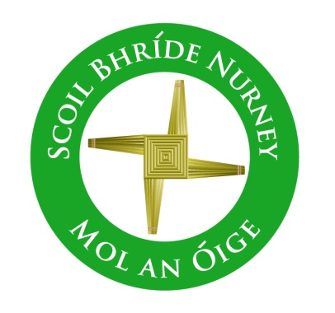
Scoil Bhríde,
Nurney,
Principal – Dr. Vinny Thorpe
Dep. Principal – Catherine Owens

County Kildare.
Tel/Fax: (045)526767
Email: sbnurney@gmail.com
www.nurneyns.com
Roll no: 16345A

Social Media Group Guidelines

Dear Parent(s)/Guardian(s)
Many of you may be members of WhatsApp or other social media groups that connect parents in a particular class. Ideally, group chats can be useful places to share information, receive updates and reminders, as well as sharing advice. Most of the time, group chats can be a great resource. But, as with many things in life, there are those unfortunate times where someone in the group may say something inappropriate or spread misinformation. For peace of mind and to comply with current best practice and law, here are some guidelines which you may find useful:

- If you have a query or concern about a teacher or the school management team, it is best to go and talk to them directly by prior appointment. Face to face is always the best way.
- Please be mindful about how you behave online. Reflect on the example you are setting for those closest to you. Social media posts have in the past been compared to ‘mob road rage’ behind ‘one’ wheel. Avoid blaming, shaming and comparing.
- When writing, remember that whatever you say on social media may be forwarded to someone else, and in a few minutes, it may be seen (whether by text or screenshot) by the entire school (including pupils and staff).
- If you feel uncomfortable about what’s being written in a group of which you are a part, for your own well-being and non-implication, the advice would be to leave the group. The law in Ireland is very strict about posting negative, libel and defamatory statements about people through social media platforms.
- Parents/Guardians and pupils in all class levels who engage in any social media forum must, at all times, demonstrate respect for all members of the school community (including pupils and staff).
- Parents/Guardians and pupils must not breach confidentiality, defame or make threats to any person in the school community.
- The Board of Management does not tolerate any form of defamation or intentional harm practiced through social media platforms. The school is clear in its policy for parents and pupils about the use of social media outlets and/or forms. Instances or evidence (such as screenshots etc.) of proven and intentional breach of the above will result in sanctions, that may include suspension from the school and/or referral to the Gardaí.
Food for thought! Please read below for some interesting statistics!

- Research carried out by Massachusetts Institute of Technology in 2018 found that false stories are 70% more likely to spread on Twitter than the truth. A similar pattern can emerge on parents’ WhatsApp groups.

- There’s a lot at stake if parent-school relationships break down. The University of Sussex found positive school-family relationships are a predictor of academic achievement.

- A 2021 Ipsos MRBI Veracity Index tracking public trust in key professions found that social media influencers are trusted by only 6% of the population. Teachers are trusted by 88%.

- A study in the International Journal of Learning, Teaching and Educational Research into school WhatsApp groups, found that there is no substitute for face-to-face communication, which creates trust and a ‘formal’ professional working relationship between parents and educators.

Thank you for your assistance with all the above, and please be safe online!

