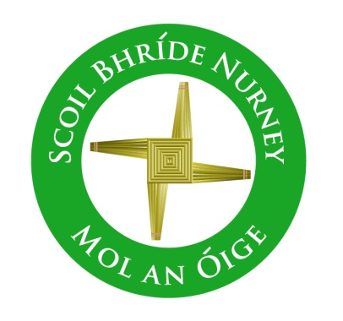
Scoil Bhríde,
Nurney,
Principal – Dr. Vinny Thorpe
Dep. Principal – Catherine Owens

County Kildare.
Tel/Fax: (045)526767
Email: sbnurney@gmail.com
www.nurneyns.com
Roll no: 16345A

4th Class 2023 – 2024
Book List

- New Wave English in Practice 4th Class (Prim-Ed)
- Ready to Write F1 (EDCO)
- Master your Maths 4 (Fallons)
- Starlight Combined Reading and Skills Book 4th Class (Folens)
- Caint is Comhrá 4 (Fallons)
- Léigh sa Bhaile D (Fallons)
- Busy at Maths 4 (Fallons)
- Small World History 4 (Fallons)
- Small World Geography and Science 4 (Fallons)
- ‘Grow in Love’ text book 4th class (veritas)

Please label all of your child’s belongings, stationery, uniform and tracksuit tops, coats etc.

Thank you for your co-operation and looking forward to a great year ahead!
Class Teacher

