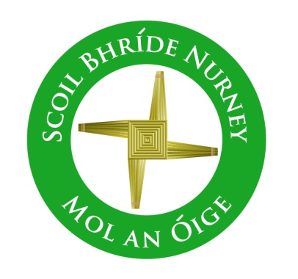
Scoil Bhríde,
Nurney,
Principal – Dr. Vinny Thorpe
Dep. Principal – Catherine Owens

County Kildare.
Tel/Fax: (045)526767
Email: sbnurney@gmail.com
www.nurneyns.com
Roll no: 16345A

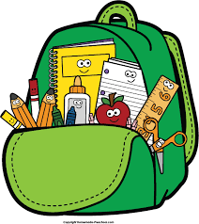
1st Class 2023 – 2024
Additional requirements

- Items to be purchased and labelled by parents in advance of September 2023:
(We have also indicated the ‘likely’ costs of these required items at best value stores)
- 8 x HB pencils (triangular grip) clearly labelled and sharpened (40 cent each)
- Packet of colouring pencils/‘Twistables’/similar (NO markers or gel pens) (€3.49)
- Eraser and pencil sharpener (labelled) (99 cent each)
- Long 30cm ruler (99 cent)
- 1 x Large Pritt stick (labelled) (€1.99)
- 2 x mesh/plastic button/zip wallet Folder (A4 size) (€2.95 each)
- 2 x red pens (35 cent each)

- €50 to be paid to class teacher or online by mid-September 2023 (if paying by cash/cheque this should be in a sealed envelope with your child’s name and class printed clearly on it)

This amount will be allocated to cover the cost of art and craft supplies and photocopying throughout the year ahead.
Please label all of your child’s belongings, stationery, uniform and tracksuit tops, coats etc.
Books and copies will be provided under the Free Primary School Book scheme and will be in your child’s classroom in September. Please impart to your child the importance of taking care of these books as they belong to the school and must be handed up at the end of the school year for the next class.

Thank you for your co-operation and looking forward to a great year ahead!

___________________
Class Teacher

