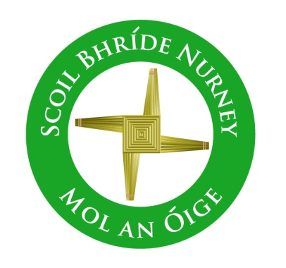
Scoil Bhríde,
Nurney,
Principal – Dr. Vinny Thorpe
Dep. Principal – Catherine Owens

County Kildare.
Tel/Fax: (045)526767
Email: sbnurney@gmail.com
www.nurneyns.com
Roll no: 16345A

opt-out form

We as parent(s)/guardian(s) of _______________________ (please insert child(s) name(s) here) wish to inform the school that we have decided to ‘opt-out’ our child from the item described below (please insert details below).

For the following reason(s) (please insert details below).

As their parent(s)/guardian(s) we will be looking after this part of their education.

Signed: _______________________________________ (Parent(s)/Guardian(s))

Date: _________________

