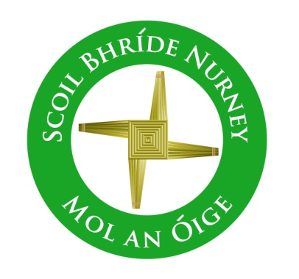
Scoil Bhríde,
Nurney,
Principal – Dr. Vinny Thorpe
Dep. Principal – Catherine Owens

County Kildare.
Tel/Fax: (045)526767
Email: sbnurney@gmail.com
www.nurneyns.com
Roll no: 16345A

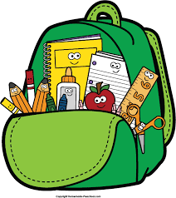
Junior Infants Class 2023 – 2024
Book List

- Starlight 4 Core Readers – Junior Infants (Folens)
- Starlight Pre-Reading Skills Book (Folens)
- Starlight Junior Infants Skills Book (Folens)
- Sounds in Action – Junior Infants (Folens)
- Ready to Write A1 (introduction to cursive) (EDCO)
- The Right Note junior infants and senior infants class (Folens)
- Cosán na Gealaí Scileanna (junior infants) (Gill)
Please label all of your child’s belongings, stationery, uniform and tracksuit tops, coats etc.

Thank you for your co-operation and looking forward to a great year ahead!
Class Teacher

