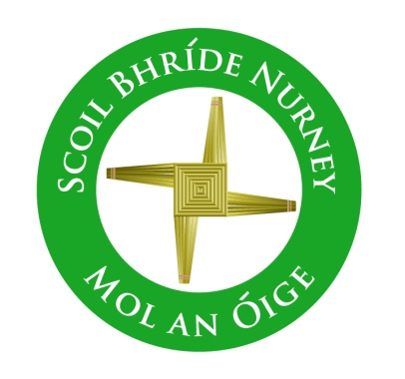
Scoil Bhríde,
Nurney,
Principal – Dr. Vinny Thorpe
Dep. Principal – Catherine Owens

County Kildare.
Tel/Fax: (045)526767
Email: sbnurney@gmail.com
www.nurneyns.com
Roll no: 16345A
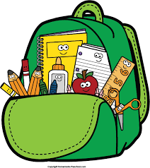

2nd Class 2023 – 2024
Additional requirements
- Items to be purchased and labelled by parents in advance of September 2023:
(We have also indicated the ‘likely’ costs of these required items at best value stores)
- Plastic A4 zip lock folder (€2)
- 1 x scrapbook A3 size (€1.99 each)
- 2 x black sharpies (fine tip) permanent markers (99 cent each)
- 10 x pencils – labelled and sharpened (€4 for 10)
- Packet of ‘Twistables’ or similar (€3.49)
- Eraser and pencil sharpener (99 cent each)
- 30cm ruler (99 cent)
- 2 x large Pritt stick – labelled (€1.99 each)
- Highlighter (any colour) – labelled (99 cent)
- Tin whistle in the key of ‘D’ – labelled (€5.99)
- 2 x Whiteboard markers – labelled (50 cent each)
- 2 x Blue/black pens – (35 cent each)

- €35 to be paid to class teacher or online by mid-September 2023 (if paying by cash/cheque this should be in a sealed envelope with your child’s name and class printed clearly on it)

This amount will be allocated to cover the cost of art and craft supplies, homework journal and photocopying throughout the year ahead.
Please label all of your child’s belongings, stationery, uniform and tracksuit tops, coats etc.
Books and copies will be provided under the Free Primary School Book scheme and will be in your child’s classroom in September. Please impart to your child the importance of taking care of these books as they belong to the school and must be handed up at the end of the school year for the next class.

Thank you for your co-operation and looking forward to a great year ahead!

___________________
Class Teacher

