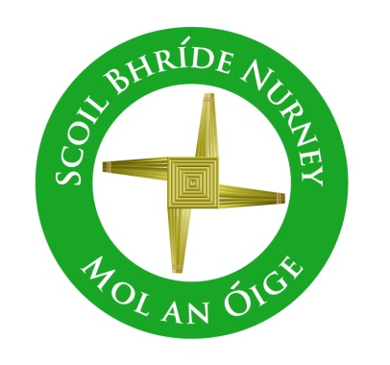
Scoil Bhríde,
Nurney,
Principal – Dr. Vinny Thorpe
Dep. Principal – Catherine Owens

County Kildare.
Tel/Fax: (045)526767
Email: sbnurney@gmail.com
www.nurneyns.com
Roll no: 16345A

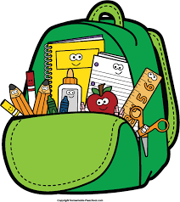

5th Class 2026 – 2027
Additional requirements
- Items to be purchased and labelled by parents in advance of September 2026:
(We have also indicated the ‘likely’ costs of these required items at best value stores)
- 2 x large Pritt sticks (labelled with name) (€1.99 each)
- Sharpener and rubber (99 cent each)
- 3 good quality handwriting pencils (HB brand recommended) (labelled) (50 cent each)
- 2 highlighters (99 cent each)
- 2 red and 1 blue pen and 1 black pen (bic) and 2 rub-out pens (black or blue) (50 cent each)
- 2 whiteboard markers (blue or black) and small whiteboard rubber (70 cent each)
- 2 fine tipped black permanent marker (€3.99 for two)
- 1 packet of colouring pencils/Twistable crayons (labelled) (€3.49)
- Maths set (including compass, protractor etc. make sure protractor is filled with no hole in middle) (€2.49)
- 1 x 30cm ruler (99 cent)
- 1 x A4 and 1 x A3 Heavy Duty plastic folders (mesh and ziplock style) (€3.99 each)
- A4 Sketch pad (€2.50)
- 1 x Calculator (6.99 each)
- Please label all belongings, lunch boxes, drinks containers, school tops and coats

- €70 to be paid to class teacher or online by mid-September 2026 (if paying by cash/cheque this should be in a sealed envelope with your child’s name and class printed clearly on it)

This amount will be allocated to cover the cost of art and craft supplies, homework journal and photocopying throughout the year ahead.
Please label all of your child’s belongings, stationery, uniform and tracksuit tops, coats etc.
Books and copies will be provided under the Free Primary School Book scheme and will be in your child’s classroom in September. Please impart to your child the importance of taking care of these books as they belong to the school and must be handed up at the end of the school year for the next class.



Thank you for your co-operation and looking forward to a great year ahead!

___________________
Class Teacher

