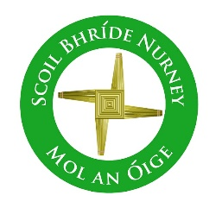
Scoil Bhríde Nurney
Home Learning
April
December Home Learning
Class / Book Name | A Way with Words | Busy at Maths | Small World
Junior Infants | Unit 12 | Pages 82 – 98 | Pages 43 – 48
Senior Infants | Unit 12 | Pages 81 – 99 | Pages 43 – 48
1st Class | Unit 12 | Pages 137 – 149 | Pages 78 – 81
2nd Class | Unit 12 | Pages 136 – 147 | Pages 72 – 77
3rd Class | Unit 12 | Units 21 | Unit 15  (History, Geography and Science)
4th Class | Unit 12 | Units 21 | Unit 15  (History, Geography and Science)
5th Class | Unit 12 | Units 21 | Unit 15  (History, Geography and Science)
6th Class | Unit 12 | Units 21 | Unit 15  (History, Geography and Science)
- All the above listed books are available free online at https://www.cjfallon.ie/
- Children can do all of the above work and write all their answers in the one same copy. Please write on the front of this copy your name and the title of “Home-Learning”
- Please write the date on all your work and a subject heading
- Any queries on this work can be sent to your child’s class teacher at sbnurney@gmail.com
- When your child returns to school please give this copy to your class teacher for review
- This work is in line with the work being carried out in class

