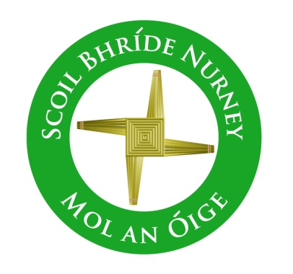
Scoil Bhríde,
Nurney,
Principal – Dr. Vinny Thorpe
Dep. Principal – Catherine Owens

County Kildare.
Tel/Fax: (045)526767
Email: sbnurney@gmail.com
www.nurneyns.com
Roll no: 16345A

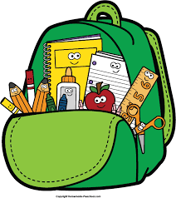

2nd Class 2026 – 2027
Book List

- Starlight Core Reader 2nd Class (Folens)
- Small World – History, Geography and Science – 2nd class (Fallons)
- Starlight Skills Book 2nd Class (Folens)
- Starlight Combined Reading and Skills Book 2nd Class (Folens)
- Master your English 2 (Fallons)
- Caint is Comhrá 2 (Fallons)
- New Busy at Maths 2 (Fallons)
- Master your Maths 2 (Fallons)
- Ready to Write 2nd Class D1 (Edco)
- Spell it 2 (Folens)
Please label all of your child’s belongings, stationery, uniform and tracksuit tops, coats etc.


Thank you for your co-operation and looking forward to a great year ahead!
Class Teacher

