
Use of School Premises Policy
2016+

Board of Management Scoil Bhríde Nurney
2016+
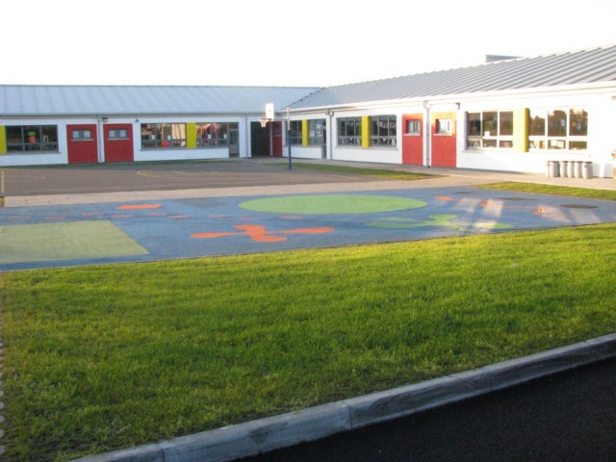

Scoil Bhríde

Use of School Premises Policy

External group use of the school premises for whatever purpose is dependent on compliance with the following directions:

- Application in writing of proposed events to Chairperson of the Board of Management with all details, including proposed activity, number of people/children involved, duration of hire etc.
- Prior to the commencement of the event/activity, evidence of appropriate insurance including a copy of its current Public Liability Insurance policy must be provided to the Board of Management (unless the BOM agrees alternative arrangements). This in turn will be sent to Scoil Bhríde Nurney’s school insurer to be processed and assessed). In addition prior to the commencement of the event/activity a separate letter of specific indemnity to the Board of Management, Patron and Trustees of the school must be provided. This too will be sent to Scoil Bhríde Nurney’s school insurer to be processed and assessed). No loss must accrue to the Board of Management/Patron/Property Owners/Trustees and/or the Department of Education and Skills from the Organization/Body’s use of School’s facilities.
- The third party is required to comply with the school’s Safety Statement and Fire Evacuation Procedure and to confirm that it will comply with all relevant legislative and other requirements including Health and Safety and Data Protection.
- The nature of the activities for which the school is hired should be in keeping with the general educational aims and/or ethos of the school.
- The standard and quality of organization, discipline and instruction (where it applies) should be in keeping with the professional standard of the school.
- Where it applies, the quality of care towards and responsibility shown to children involved in specific activities should be in keeping with that of the school.
- Date(s) must be agreed with BOM in advance.
- Only data neutral rooms can be assigned by the BOM. They being the library room and the PE Hall (with the exception of teaching staff). Classrooms, special education rooms, staffroom, offices and ancillary rooms (with the exception of toilets) are not available for use/hire. To cover the cost of energy and opening/closing, the current rate for hire of the library room is €50 per hour. The rate for hire of the PE Hall is €100 per hour.
- Due to cleaning schedules and insurance requirements the PE Hall is unavailable during the school term (including weekends). Due to cleaning schedules and staff usage the library room is unavailable on Fridays.
- A written agreement must be signed by BOM and the organizers of any event.
- The supervision of children/adults attending activities is the responsibility of the instructor present on behalf of the group/individual hiring the school. (This includes the supervision and care of the clients waiting beforehand and waiting to be collected afterwards).
- Any brochure/publicity should state that the event is not being run by the school authorities.
- Responsibility rests with the group/individual who is hiring the school for communicating with parents/guardians/clients about:
(a) Starting/finishing dates and times
(b) Cancellations, re-scheduling etc.
(c) A contact phone number should be provided to parents/guardians/clients by the organizers through which all questions are directed. The school phone number is not to be provided as a contact number.
- The organizer present on behalf of the group/individual hiring the school is responsible for:
- Health and Safety of participants.
- Ensuring that the school’s no smoking status is upheld.
- Ensuring that participants clearly understand that they are not permitted or authorized to access or enter any other rooms except the room being hired by the applicant and the corridor toilet. Any unauthorized entry will deem this agreement and contract null and void.
- Providing evidence of their Garda Vetting to the school (if applicable)
- Providing the Board of Management with a letter stating that they have appropriate Child Safeguarding Procedures in place.
- Ensuring that the school’s no smoking status is upheld
- Turning off lights and closing all windows and doors used
- Returning equipment and furniture to proper storage point
- Third party equipment cannot be stored on the school premises.
- Re-arranging furniture (if applicable)
- Arrange cleaning of toilets and any rooms used
- Any additional necessary cleaning (e.g, corridors, playground)
- All cleaning up afterwards. The facilities must be left in a clean and tidy condition in their original state and all property belonging to the group removed/stored as agreed.
- Make good any damages
- Provision of materials
- Due care in the use of any school equipment
- Setting the alarm and locking up the building and grounds (if requested to do so).
- Reporting any damage to property or equipment in writing to the Board of Management. The Patron/Board of Management/Property Owners/ Trustees reserves the right to recoup any costs incurred.
- The organizer hiring the school and their participants are required to abide by signs on display, to adhere to school rules, health and safety requirements, including no smoking stipulations and to other relevant school policies, procedures and other measures in place to safeguard the safety and welfare of the school’s pupils/staff.
- Requests made by any school staff representatives who may be on duty before, during or after meeting/activity times are to be complied with promptly and in full.
- School property is to be vacated at the appointed times.
- The group are required to comply with the school’s Safety Statement and Fire Evacuation Procedure and to confirm that they comply with all relevant legislative and other requirements including Health and Safety, Child Protection and Garda Vetting.
- Any incidents which occur on school premises which could give rise to an insurance claim or which fall under the Health and Safety Policy must be reported to the Board of Management representative immediately or as soon as practically possible.
- The principal and/or Board of Management will decide the limitation of numbers at any such meetings.
- Meeting/activities can be held only at times sanctioned by the Principal/Board of Management.
- The agreed school hire charges should be paid by cash or cheque to the Board of Management of Scoil Bhríde Nurney, before the commencement of the event/activity. The rate will be decided on a case-by-case basis.
- The school reserves the right to use the room for its own purposes.
- The BOM will periodically review the hire of the school premises and should the need arise, to suspend the hire should they deem it necessary. The school reserves the right to discontinue the use of the hall/room at any time for any specific reason. The principal will have responsibility for monitoring/overseeing the process and will report to the Board of Management accordingly.
- There shall be no disruption to any teacher, child or staff member. The group shall use their own resources and not those of the school. They will have the use of the specific room which approval has been requested and granted only.
- All course activity organizers shall be responsible for their own tax liabilities. They will provide a tax clearance certificate with their application for use of the school premises.
- The organizers are responsible for familiarizing themselves with all Health and Safety Procedures.
- All course organizers shall receive this policy and shall sign it thus agreeing to the aforementioned.
- All course organizers shall receive, read and sign the attached contract (which forms part of this policy) for the rental/leasing of premises for Scoil Bhríde Nurney
- This agreement will be valid, subject the above conditions, for one year.
- The Organization/body is responsible for ensuring that all members using school facilities are aware of these conditions.

I/we _____________________________________ agree to these rules and procedures for my/our ___________________________________running on ___________________ (indicate dates).

I/we have provided: (please tick)
- Evidence of appropriate insurance including a copy of my/our current Public Liability Insurance policy to the Board of Management
- A separate letter of specific indemnity from my/our insurer to Board of Management, Patron and Trustees of Scoil Bhríde in respect of the use of the school premises.
- Evidence of Garda Vetting to the school (Applicable/Not Applicable)
- A letter to the Board of Management stating that I/we have appropriate Child Safeguarding Procedures in place.
- Confirmation that I/we have child safeguarding measures in place
- A tax clearance certificate.
- The signed License Agreement below agreeing to all the above terms and conditions.

Signed by licensee: _________________________ Date: ________________

License Agreement for the Use of Scoil Bhríde Nurney School Premises outside of School Hours

Name of Licensee Group

Address

Phone  (this cannot be the school phone number) | Mobile |  | Landline
Email
(this cannot be the school email)

Purpose for which the premises will be used

Number of participants

Precise Period of License | From |  | To
License details
(e.g. day, start time, finish time, how many days per week etc.)
Insurance company
(please enclose copy of policy)

Contact person

Phone

- This License Agreement is valid for the period ________ to ________ (maximum 10 month period only) and is subject to review in _______________ (name of month). The Board of Management reserves the right to terminate the agreement at any time if school circumstances change.
- I will pay the Board of Management of Scoil Bhríde Nurney the agreed rate of €________per week/day (delete as appropriate) for the duration of the rental period.
Cheques only and payable in advance to “Board of Management of Scoil Bhríde Nurney”
(As per Department of Education guidelines “any provision should be self-financing and should, at a minimum, cover maintenance, utility bills, additional insurance costs, legal requirements and other overheads or associated costs” e.g. opening up, locking up, light and heat etc.)
- I confirm that the premises is suitable for the delivery of my service/activity
- I undertake to repair any damage to the premises and equipment and return it to its former state.
- I will ensure that all school equipment is kept safely and properly stored.
- I agree to use only the room(s) agreed in advance
- I agree that the school premises will only be used for the activities agreed in advance.
- I agree in full to the rules and procedures outlined in Scoil Bhríde’s “Use of School Premises Policy” and have provided the same in writing.

Any changes in these activities should be agreed in writing with the Board of Management.

Signed by Licensee: ___________________________ Date: _________________

Signed on behalf of the BOM: __________________ Date: __________________

Ratification of Use of School Premises Policy

This policy was adopted by the Board of Management on _________________

Signed: _________________________ Signed: __________________________
Chairperson of Board of Management Principal

Date: __________________________ Date: __________________________

Date of next review: __________________

