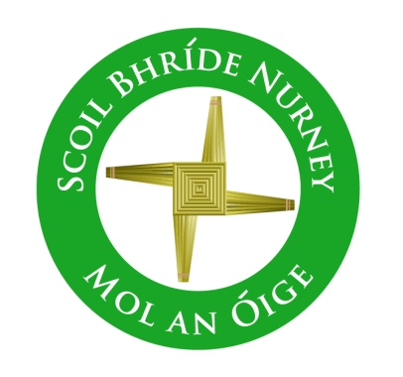
Scoil Bhríde,
Nurney,
Principal – Dr. Vinny Thorpe
Dep. Principal – Catherine Owens

County Kildare.
Tel/Fax: (045)526767
Email: sbnurney@gmail.com
www.nurneyns.com
Roll no: 16345A

An important letter for all families to read!!

May 2026
Hello there, Parent(s) and Guardian(s),

All primary schools across the country, including here in Nurney, have benefitted from an explosion in pupil growth since 1999. Some have termed this a “Baby Boom”. This bulge in pupil numbers has passed through all primary schools and is now currently passing through secondary schools. It reached its peak in secondary schools in 2024. This is why secondary school places have been an issue for all counties in the last 2 to 3 years.

Countrywide the number of children attending primary school is set to drop by about 120,000 over the next decade, according to new Department of Education figures. For each primary school this means a 20% drop in pupil numbers.

So, what does this mean for Nurney National School?
Such reductions inevitably will lead to change and my mission during this period of change (and I am certainly up for this challenge!) is to continue developing Nurney National School into a strong, calm place of sustainable teaching and learning for pupils of all needs. A place where teachers feel healthy and energized and given the space they need, to do what they do best...…teach!......leading to better teaching and learning outcomes for all children and a greater sense of wellbeing for all.

Reduced pupil growth is an important issue for rural and small village communities. Local shops, bars, restaurants, businesses, voluntary organizations, churches, GAA clubs and schools are vital in keeping rural settlements and small villages, like Nurney, alive. They all need each other.

Every child enrolled in our school is and will be vital during this period of national declining pupil numbers in Ireland as every child enrolled in our school helps to maintain:
- our current staffing levels of class teachers
- our current special needs provision regarding learning support teachers and SNAs
- our current finances to keep the school going, as all grants paid by the government to our school are given per pupil head.
To sustain your school and your village, I would ask everyone to do their bit and encourage anyone they know, near or far, to consider enrolling their child in your school. At the end of the day, it’s for the benefit of your local community and local organizations and ultimately your future generations.

So, what does that mean for classes in Nurney National School this September 2026?
Since 2010 Nurney National School has had 8 class teachers due to a local housing boom and the baby boom referred to earlier. Regretfully however, due to a non-drop in the pupil-teacher ratio in the last Budget, Nurney National School has fallen short of keeping its 8th class teacher since September 2023. This will likely remain the case until
- Children numbers living locally increase. This can happen with increased house building or new families moving into the area
and/or
- The Department of Education reduces the pupil-teacher ratio in any future Budget announcement. Regretfully, this was not done in the last Budget.
The Department of Education allots one teacher to approximately every 23 pupils at present. This is known as the pupil-teacher ratio. The pupil-teacher ratio is dictated annually by the government budget and schools have no control over this.

The ideal situation for teacher and pupil would be a single stream class at all levels (i.e., one of each class) with no more than 20 pupils per class. However, the current Department of Education system does not allow for this. A school principal is therefore left with the responsibility for mixing classes where numbers would otherwise be too big or too small in one class. With the resources given by the Department of Education, it is left to the school principal to decide how best to organize classes for each September with a view to providing the best educational opportunities for all children.

In a nutshell, this means in the absence of an 8th class teacher, I would have to divide and combine 8 class groups into 7 classes. This would result in Nurney National School having two super-sized mixed classes with 40 pupils in one class and 36 pupils in the other.

However!!..........

My vision for this school, is one based on teaching and learning excellence, free from unnecessary distraction to raise academic standards and levels of well-being for all and give the children we teach the best chance possible in our 21st century world.

To help achieve that aim I am determined to maintain our 8 classrooms and current small class size. I believe in this vision so strongly, that I am once again for a fourth year putting myself forward to teach a class in September 2026, even though I am not required to do so, as under the current Department of Education system, a principal does not teach a class in a school with 7 classroom teachers or more, the principal being released from teaching a class to fulfill ever growing complex and demanding administrative duties and walk the school, therefore sometimes being referred to as a ‘walking’ or ‘admin’ principal.

With the backing of the Board of Management, staff and my family it is my intention to teach a class in September 2026 once again so that we can:
- Maintain our current 8 classrooms
- Keep our class sizes small (in terms of pupil numbers) and
- Make that vision a reality

To conclude
I hope you found this letter useful in explaining the road ahead. Details regarding classes and their designated teachers for September 2026 issued in the last few weeks, as per usual. As always, we look forward to your utmost support in the year ahead.

Many thanks,
God Bless,

___________
Dr. Vinny Thorpe
Principal

