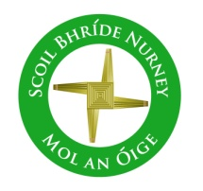
Scoil Bhríde
Nurney, Co. Kildare
Telephone: (045) 526767
www.nurneyns.com
sbnurney@gmail.com

6th December 2023
Dear Parents/Guardians

It’s a pretty full newsletter this week, so please read both sides!!!!
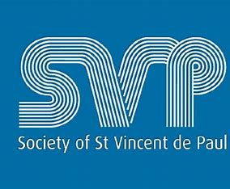

Our School’s Annual Winter Fest Hamper Raffle organized by 6th class for all pupils in memory of Catherine O’Donoghue late of Walterstown Nurney (partner of our great school caretaker Pat) takes place soon. All donations go to ‘St. Vincent De Paul’

Tickets for the raffle will be sold to pupils in the school by 6th class during December. Tickets are 1 Euro per line.
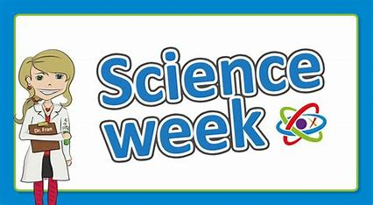
Winners of the raffle will be announced at our December school assembly. The winner will get a hamper. There are two hampers. One for junior infants to 2nd class and one for 3rd to 6th class. All raffle ticket purchases are welcome and greatly appreciated. Thank you for supporting St. Vincent De Paul.

Science Week 2023
Congrats to all pupils who took part in Science Week 2023 last week. Congrats also to the many pupils who received special commendations for their project work. A special word of thanks to all our pupil’s families for all their amazing work and dedication at home on the projects. A big thank you to 6th class teacher Ms. Butler, her pupils and indeed all the school staff for the massive logistical work done in coordinating and supervising the entire event. An amazing team. Well done!

Parent Teacher meetings
Parent Teacher meetings will be held on a phased basis in February. You will receive notification from your child’s class teacher in January. Thank you.

Drum lessons payment due – all pupils
A 4-week course of drumming classes for all pupils with a specialist instructor started on November 20th. To cover the cost a payment of 8 Euro is now due from each pupil. This can be paid online or by cash. Thank you to all who have paid in full to date.

Gymnastics payment due – all pupils
A 4-week course of gymnastics classes for all pupils with a specialist instructor started on October 23rd. Payment of 6 Euro from each pupil is now due. Thanks.

3rd class Swimming payment due!
A six-week course of swimming classes in K-Leisure Athy for 3rd class began on November 8th. Payment of 50 Euro from each 3rd class pupil is now due. Thank you to all who have paid in full to date.

A six-week course of swimming in K-Leisure Athy for all other senior classes will start as follows:
6th class – January 10th 2024
4th class – April 10th 2024

Dates for your diary
- Annual School Book Fair –booked for Spring 2023
- End of Term School Mass – Tuesday December 19th @ 11:40am in School Hall.
- School will close for Christmas on Friday December 22nd for all pupils at 12.30pm. Buses have been told. The school will re-open on Monday January 8th 2024 for all pupils at 9.20am
- The Parish office wishes to inform you that Communion for families with children in 2nd class will be May 18th 2024 @ 11:30am in Nurney Church
- The Parish office wishes to inform you that Confirmation for families with children in 6th class will be April 20th @ 11:30am in Nurney Church

As we head into the cold and wet Winter months ahead, we ask all parents to please ensure that their children come to school prepared with the proper clothing needed for all weathers.
As Dr. Thorpe’s Mum used to say “There is no such thing as bad weather, just bad clothing”

Substitution crisis in primary schools
As you may be aware from news channels, newspapers and social media, currently there is a severe shortage of primary school teachers and special needs assistants in our country and county. At times it has been a challenge to keep schools operational. However, with the great team spirit within our school staff we have managed to plug any gaps as best as we can using whatever staff we have been able to pull from other duties (such as special needs teachers, principal and deputy principal, work placement teachers etc.), however we have also had to send pupils to other classes where no substitute cover was available or not funded by the Department of Education. Qualified primary teachers and trained SNAs are currently like gold dust. To protect the continued operation of the school and the pupils’ teaching and learning, it has been and still is vital, in as much as is possible, to protect the health and well-being of the staff that we are lucky enough to have, because there are literally no easy replacements to be found.
Thank you to all parents and pupils for your continued past, present and future support in this endeavour.
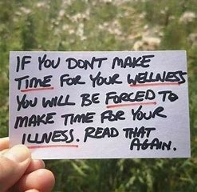

Home Learning page on our school website
If your child has to isolate and stay out of school due to sickness, please go to the following link on our school website to access the school work they would be doing at that time in class https://www.nurneyns.com/home-learning

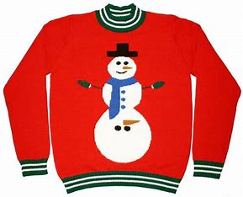
Christmas Jumper Day!
Wednesday, December 20th we invite all pupils, if they so wish, to wear a Christmas jumper in our school!

Wednesday Note and school information also available
on www.nurneyns.com
Thank you for your co-operation with the above.

__________________________
Dr. Vinny Thorpe – Principal
Ed.D (SL) M.Ed (SL), MA.Comp.Mus, H.Dip.Prim.Ed, H.Dip.Mus.Tech, P.Grad.Dip.Ed.St(SEN), B.Mus.Ed(H.Dip.Ed), Dip.Mus.Ed, T.Dip.ICT

