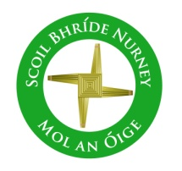
Scoil Bhríde
Nurney, Co. Kildare
Telephone: (045) 526767
www.nurneyns.com
sbnurney@gmail.com
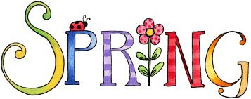
7th February 2024
Dear Parents/Guardians

Enrolment (September 2024) Closing Date is February 14th
For more details, please see the reverse side of this note. Thank you.

6th class Swimming payment due!
A six-week course of swimming classes in K-Leisure Athy for 6th class began on Wednesday 10th January. Payment of 50 Euro from each 6th class pupil is now due. Thank you to all who have paid in full to date.

A six-week course of swimming in K-Leisure Athy for all other senior classes will start as follows:
4th class – April 10th 2024

Dance lessons for all pupils
A 6-week course of dance classes for all pupils with a specialist instructor starts on February 20th. Payment of 5 Euro from each pupil is now due. Thank you.

World Book Day
To celebrate World Book Day all pupils are being invited to dress up as their favorite book character on Thursday March 7th. So please start planning your costumes! The Newspaper is sending a photographer.

School Assembly
Well done to all our pupils who received well done awards over the last month for great lining up, working hard, following teacher instructions, following the school rules, playing fair and nice in our school by showing kindness, compassion, respect, saying sorry and offering forgiveness. Congratulations to the following pupils who were pulled out of our “Well Done Award Prize Draw” Frank – Senior Infants, Katie – 2nd class,
Ryan – 4th class, Vagmi – 5th class

February and March the months of all seasons!
As we head into a variety of weathers, please ensure your child has appropriate outdoor clothing for each and every school day. Thank you

Saint Brigid’s Mass and Catholic Schools Week
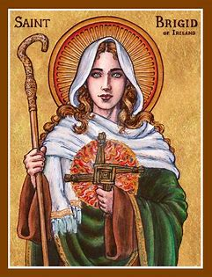
Thanks to the all the pupils of 3rd class and Ms. O’Connor Desmond, all our pupils, our entire school team, Ms. Doyle, Fr. Adrian and Kathleen and all those who joined us, for helping to celebrate Saint Brigid’s day with a beautiful mass last Friday as part of Catholic Schools Week. What a lovely way to welcome the arrival of Spring!

Dates for your diary
- Parents Association Bake sale – Tuesday February 13th
- Mid-term break closure – School will be closed on February 15th and 16th
- School closed on Friday March 1st for all pupils as staff must attend a Department of Education seminar on the New Primary Maths Curriculum.
- School Book Fair – March 6th and 7th (pupils) March 11th 2:20pm-3pm (parents)
- School closed to facilitate referendum voting – Friday March 8th 2024.
- Easter Bun sale for pupils – Wednesday March 13th 2024
- Dress up in Green Day – Friday March 15th 2024
- School will be closed on Monday March 18th for Saint Patrick’s Day.
- School will close for Easter on Friday March 22nd for all pupils at 12.30pm. Buses have been told. The school will re-open on Monday April 8th 2024 for all pupils at 9.20am
- The Parish office wishes to inform you that Communion for families with children in 2nd class will be May 18th 2024 @ 11:30am in Nurney Church
- The Parish office wishes to inform you that Confirmation for families with children in 6th class will be April 20th @ 11:30am in Nurney Church.

Parents Association Bun Sale
The Parents Association are holding a Bake Sale February 13th for pupils with all funds going towards their annual membership subscription to the National Parents Council, a treat for 6th class pupils making their confirmation (including those from 6th class who are not) and an Easter egg for each child. All donations of cakes, buns and treats are most welcome! Thank you.

Wednesday Note and school information also available
on www.nurneyns.com
Thank you for your co-operation with the above.

__________________________
Dr. Vinny Thorpe – Principal
Ed.D (SL) M.Ed (SL), MA.Comp.Mus, H.Dip.Prim.Ed, H.Dip.Mus.Tech, P.Grad.Dip.Ed.St(SEN), B.Mus.Ed(H.Dip.Ed), Dip.Mus.Ed, T.Dip.ICT

* Junior Infant Enrolment Process and Timeline

- “Expression of Interest in Enrolment Form” available from school website all year long. This Form puts applicants on a mailing list only.
- Enrolment forms posted to families on mailing list first Friday of February.
- Enrolment Forms to be returned to the school fully filled in by 3pm the last school day before February mid-term break.
- BOM meets the second Tuesday in March to (firstly) prioritize Enrolment Applications based on the Admissions Policy criteria (secondly) create a list of offered places and (thirdly) create a waiting list for places.
- Letters offering a place are sent out on the second Friday of March. Letters informing applicants they are on the waiting list are sent out on the second Friday of March also.
- Acceptance of offered place letters are to be returned to the school by 3pm the last school day of March.
- During the month of April, the BOM meets to (firstly) discuss, create and finalize an accepted places list (secondly) to review the waiting list and decide if places are available for those on the waiting list (thirdly) issue letters to those who have been successful/unsuccessful in gaining a place from the waiting list.
- The induction day for new junior infants and their parents is held on a date in June.
- The school’s Annual Admissions Notice can be accessed here www.nurneyns.com/enrolment

