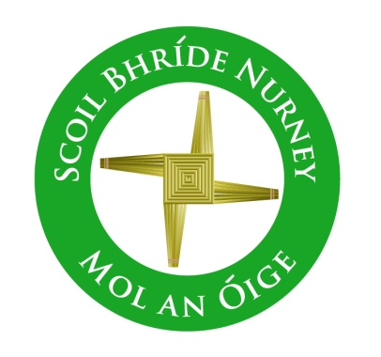
Scoil Bhríde,
Nurney,
Principal – Dr. Vinny Thorpe
Dep. Principal – Catherine Owens

County Kildare.
Tel/Fax: (045)526767
Email: sbnurney@gmail.com
www.nurneyns.com
Roll no: 16345A

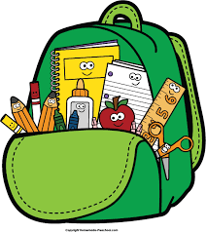

6th Class 2026 – 2027
Book List

- Master your Maths 6 (Fallons)
- Master you Grammer 6 (Fallons)
- Master your English 6 (Fallons)
- Ready to Write H1 (cursive) (EDCO)
- New Busy at Maths 6 (Fallons)
- Caint is Comhrá 6 (Fallons)
- Léigh sa Bhaile F (Fallons)
- Small World History 6 (Fallons)
- Small World Geography and Science 6 (Fallons)
- ‘Grow in Love’ text book 6th class (veritas)

Please label all of your child’s belongings, stationery, uniform and tracksuit tops, coats etc.


Thank you for your co-operation and looking forward to a great year ahead!
Class Teacher

