
Class Allocation and Mixed Classes Policy
2021+

Board of Management Scoil Bhríde Nurney
2021+
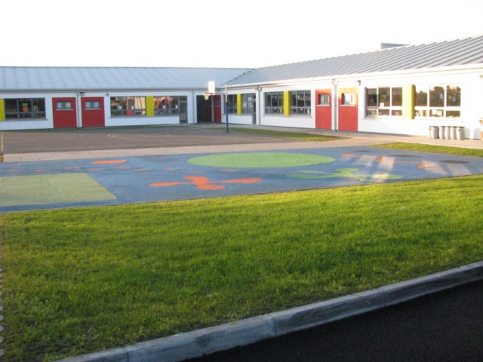

Scoil Bhríde

Class Allocation and Mixed Classes Policy

Introduction and Rationale
Depending on the number of teachers sanctioned to Scoil Bhríde Nurney by the Department of Education and in the interest of providing the best education for all students, it may from time to time be necessary to allocate, divide and combine class groups into mixed classes.

Aims and Objectives

- To provide a framework for the allocation and mixing of classes
- To outline the criteria on which children are selected to be placed in classes.

Framework for the allocation and mixing of classes
At the time of planning the classes for the coming year, the principal will look at the overall numbers in each year group and the number of teachers available to teach them. The Department of Education decides the number of teachers available to the principal based on pupil enrollments.

The Department of Education allots one teacher to each group of 23 pupils at present. This is known as the pupil-teacher ratio. The pupil-teacher ratio is dictated annually by the government budget and schools have no control over this.

The ideal situation for teacher and pupil would be a single stream class at all levels with no more than 20 pupils per class. However, the current Department of Education system does not allow for this.

The principal is therefore left with overall responsibility for mixing classes where numbers would otherwise be too big or too small in one class. The Department of Education’s still however, wants class size should be as equitable as possible across all class levels.

With the resources given by the Department of Education, the principal will therefore decide how best to organize classes with a view to providing the best educational opportunities for all children. The principal in consultation with the current class teacher(s) and if necessary, with previous teachers of the class or classes involved will draw up a list of possible groups.

Criteria for placing children in particular class groups
Scoil Bhríde Nurney will endeavour to group the children in such a way as to maximize the learning outcomes for all, while taking into consideration the following criteria:

- It is considered best to form mixed-ability groups
- Gender balance
- The dynamics of the class must be considered. Emotional, behavioural and social factors which could upset or enhance the dynamic of the new class should be taken into consideration when forming new groupings.
- SNA access and allocation
- Mixed classes may also be formed alphabetically or by age.

The process of forming new friendships is a life skill which is important to develop. A positive and supportive attitude from parents is a key element in achieving a successful outcome in the new groups. It will seldom be possible to satisfy all demands for groups of friends to be kept together. In addition, sometimes pupils move to or from the school without informing the school in advance. This is outside the control of the principal. This decision will ultimately lie with the principal, who will use their professional judgement to consider the needs of every child in the class. It would be the intention however, that once a new class is formed, every effort would be made to keep that class together going forward.
The allocation of teachers to classes (mixed or otherwise)
It is the duty of the principal as per circular 16/73 to assign teaching duties. All teaching staff, under the guidance of the principal are encouraged to participate in and contribute to the implementation of an effective and equitable class allocation policy, based on compromise and consensus. Any communication, outside of teaching staff, to exert influence on the principal in carrying out their core duty (as per circular 16/73) of assigning teaching duties will not be engaged with.

Roles and responsibilities
The overall responsibility for the implementation of this policy lies with the principal and teachers.

Review
This policy will be reviewed as part of Scoil Bhríde Nurney’s annual 3-year policy review cycle.

Ratification of Class Allocation and Mixed Classes Policy

This policy was adopted by the Board of Management on _________________

Signed: _________________________ Signed: __________________________
Chairperson of Board of Management Principal

Date: __________________________ Date: __________________________

Date of next review: __________________

