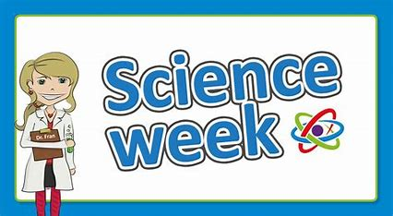
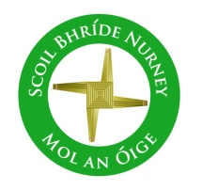
Scoil Bhríde
Nurney, Co. Kildare
Telephone: (045) 526767
www.nurneyns.com
sbnurney@gmail.com

3rd December 2025
Dear Parents/Guardians

3rd class Swimming payment due!

A six-week course of swimming classes in K-Leisure Athy for 3rd class started on November 5th.

Payment of 80 Euro from each 3rd class pupil is now due.
Thank you to all who have paid in full to date.


A six-week course of swimming in K-Leisure Athy for all other senior classes will start as follows:
6th class – January 7th 2026
4th class – April 15th 2026

School Assembly
Well done to all our pupils who received well done awards over the last month for great lining up, working hard, following teacher instructions, following the school rules, playing fair and nice in our school by showing kindness, compassion, respect, saying sorry and offering forgiveness. Congratulations to the following pupils who were pulled out of our “Well Done Award Prize Draw” Gracie – Senior Infants, Alfie – 2nd class, Caoimhe – 3rd class, Emily – 6th class

Drumming

A 4-week course of drumming classes for all pupils with a specialist instructor started on November 7th. To cover the cost a payment of 8 Euro will be needed from each pupil. This can be paid online or by cash. Thank you.

Christmas Jumper Day!

Thursday, December 18th we invite all pupils, if they so wish, to wear a Christmas jumper in our school

Parent Teacher meetings
Parent Teacher meetings will be held on a phased basis in February/March. You will receive notification from your child’s class teacher in January. Thank you.

Parents Association Bun Sale
The Parents Association are holding a Bake Sale December 4th for pupils with all funds going towards their annual membership subscription to the National Parents Council, a treat for 6th class pupils making their confirmation (including those from 6th class who are not) and an Easter egg for each child. All donations of nut free cakes, buns and treats are most welcome! Thank you.

Science Week 2025

Congrats to all pupils who took part in Science Week 2025 last week. Congrats also to the many pupils who received special commendations for their project work. A special word of thanks to all our pupil’s families for all their amazing work and dedication at home on the projects. A big thank you to 6th class teacher Ms. Butler, her pupils and indeed all the school staff for the massive logistical work done in coordinating and supervising the entire event. An amazing team. Well done!


As we head into the cold and wet Winter months ahead, we ask all parents to please ensure that their children come to school prepared with the proper clothing needed for all weathers.
As Dr. Thorpe’s Mum used to say “There is no such thing as bad weather, just bad clothing”

Home Learning page on our school website
If your child has to isolate and stay out of school due to sickness, please go to the following link on our school website to access the school work they would be doing at that time in class https://www.nurneyns.com/home-learning

Food Parcels

At this time of year, we like to think of others less fortunate. Last year we organised a food collection for Saint Vincent de Paul (SVP) for Christmas. Your generosity was greatly appreciated. We are organising a food collection again this year. Thanks to Ms. Butler and all the girls and boys in 6th class for all their help in organising this very worthy collection this year. The deadline date for receipt of non-perishable food items, festive items (e.g. tea, coffee, biscuits, vouchers etc.) or toiletries is Friday December 12th. They can be dropped into the school office.
Thank you.

Dates for your diary
- End of Term School Mass – Tuesday December 16th @ 11:30am in School Hall.
- School will close for Christmas on Friday December 19th for all pupils at 12.30pm. Buses have been told. The school will re-open on Monday January 5th 2026 for all pupils at 9.20am
- Annual School Book Fair – March 5th and 6th 2026
- The Parish office wishes to inform you that Confirmation for families with children in 6th class will be April 25th 2026 @ 10:30am in Nurney Church
- The Parish office wishes to inform you that Communion for families with children in 2nd class will be May 23rd 2026 @ 11am in Nurney Church



Substitution crisis in primary schools
As you may be aware from news channels, newspapers and social media, currently there is a severe shortage of primary school teachers and special needs assistants in our country and county. At times it has been a challenge to keep schools operational. However, with the great team spirit within our school staff we have managed to plug any gaps as best as we can using whatever staff we have been able to pull from other duties (such as special needs teachers, principal and deputy principal, work placement teachers etc.), however we have also had to send pupils to other classes where no substitute cover was available or not funded by the Department of Education. Qualified primary teachers and trained SNAs are currently like gold dust. To protect the continued operation of the school and the pupils’ teaching and learning, it has been and still is vital, in as much as is possible, to protect the health and well-being of the staff that we are lucky enough to have, because there are literally no easy replacements to be found.
Thank you to all parents and pupils for your continued past, present and future support in this endeavour.
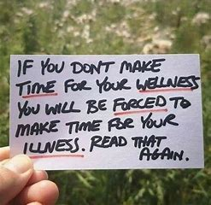

Wednesday Note and school information also available
on www.nurneyns.com
Thank you for your co-operation with the above.

______________________________
Dr. Vinny Thorpe – Principal
Ed.D (SL) M.Ed (SL), MA.Comp.Mus, H.Dip.Prim.Ed, H.Dip.Mus.Tech, P.Grad.Dip.Ed.St(SEN), B.Mus.Ed(H.Dip.Ed), Dip.Mus.Ed, T.Dip.ICT

